CPSC319 Design Document

SCORM Browser

Team #: B4

Team Name: B4

Date: February 22, 2004

Table of Contents
1 Table of Contents 2
2 Introduction 4
2.1 Scope of Document 4
2.2 Tools Used To Generate Document 4
2.3 General Comments about Low Level Sequence Diagrams 4
3 High Level Design 5
3.1 System Architecture 5
3.2 Interface Descriptions (Sequence Diagrams) 5
3.2.1 Open URL 5
3.2.2 Open Local File 6
3.2.3 Display SCORM Relational Graph 6
3.2.4 Display Attribute Display 7
3.2.5 Hide Object Tree 7
3.2.6 Show Object Tree 7
3.2.7 Save Object to Local File 8
3.2.8 Save As Other Format 8
3.2.9 Cancel 8
3.2.10 Help 9
3.2.11 Forward 9
3.2.12 Back 9
3.2.13 Select Object From History 10
3.2.14 Select Object From Tree 10
3.2.15 Select Object From Graph 11
3.2.16 Select Object From Attribute Display 11
3.2.17 Select Attribute To Sort By 12
3.2.18 Select Attribute Filter 12
3.2.19 Create Attribute Filter 12
3.2.20 Modify Attribute Filter 13
3.2.21 Delete Attribute Filter 13
3.2.22 Select Object Filter 13
3.2.23 Create Object Filter 14
3.2.24 Modify Object Filter 14
3.2.25 Delete Object Filter 14
4 Low Level Design 15
4.1 Complete Static Model (Class Diagram) 15
4.2 Main UI Package 16
4.2.1 Static Model (Class Diagram) 16
4.2.2 Dynamic Model (Sequence Diagrams) 17
4.2.2.1 Open URL 17
4.2.2.2 Open Local File 17
4.2.2.3 Display SCORM Relational Graph 18
4.2.2.4 Display Attribute Display 18
4.2.2.5 Hide Object Tree 19
4.2.2.6 Show Object Tree 19
4.2.2.7 Save Object to Local File 20
4.2.2.8 Save As Other Format 21
4.2.2.9 Cancel 21
4.2.2.10 Help 22
4.2.2.11 Forward 22
4.2.2.12 Back 23
4.2.2.13 Select Object From History 23
4.3 Data Manager Package 24
4.3.1 Static Model (Class Diagram) 24
4.3.2 Dynamic Model (Sequence Diagrams) 25
4.3.2.1 Open URL, Open Local File 25
4.3.2.2 Save Object to Local File 25
4.3.2.3 Save As Other Format 26
4.3.2.4 Cancel 26
4.3.2.5 Forward 27
4.3.2.6 Back 27
4.3.2.7 Select Object From History 28
4.3.2.8 Select Object From Tree 28
4.3.2.9 Select Object From Graph 29
4.3.2.10 Select Object From Attribute Display 29
4.3.2.11 Select Attribute Filter 30
4.3.2.12 Select Object Filter 30
4.4 Filter Managers Package 31
4.4.1 Static Model (Class Diagram) 31
4.4.2 Dynamic Model (Sequence Diagrams) 32
4.4.2.1 Select Attribute Filter 32
4.4.2.2 Create Attribute Filter 32
4.4.2.3 Modify Attribute Filter 33
4.4.2.4 Select Object Filter 34
4.4.2.5 Create Object Filter 34
4.4.2.6 Modify Object Filter 35
4.4.2.7 Delete Attribute Filter, Delete Object Filter 36
4.5 Viewers UI Package 37
4.5.1 Static Model (Class Diagram) 37
4.5.2 Dynamic Model (Sequence Diagrams) 38
4.5.2.1 Open URL, Open Local File, Forward, Back, Select Attribute Filter, Select Object Filter, Select Object From History 38
4.5.2.2 Display SCORM Relational Graph 38
4.5.2.3 Display Attribute Display 39
4.5.2.4 Hide Object Tree 39
4.5.2.5 Show Object Tree 39
4.5.2.6 Select Object From Tree 40
4.5.2.7 Select Object From Graph 40
4.5.2.8 Select Object From Attribute Display 40
4.5.2.9 Select Attribute To Sort By 41

Introduction

Scope of Document
The scope of this document is high level and low level design.

Tools Used To Generate Document
The diagrams in this document were generated using Omondo’s Eclipse UML plug-in.

General Comments about Low Level Sequence Diagrams
Some use cases share the same dynamic model (sequence diagram) for a particular package. As a result they will be grouped together and only one diagram will be provided.

To clarify the low level sequence diagrams the boundary classes (ie classes that communicate across packages) will be shown in both packages sequence diagram for a particular use case.

High Level Design

System Architecture
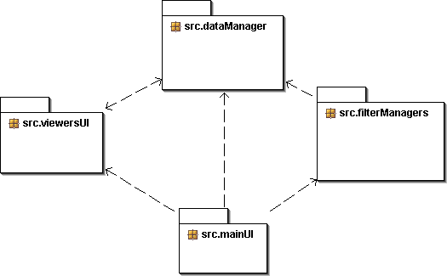

Interface Descriptions (Sequence Diagrams)

Open URL
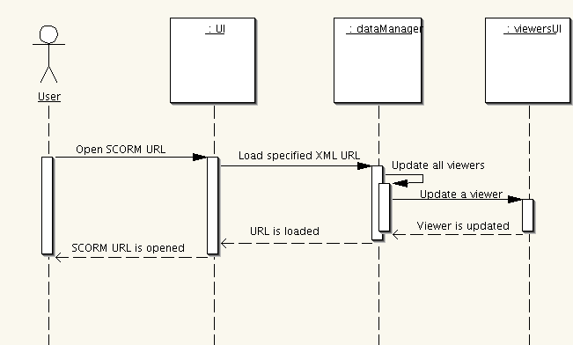

Open Local File

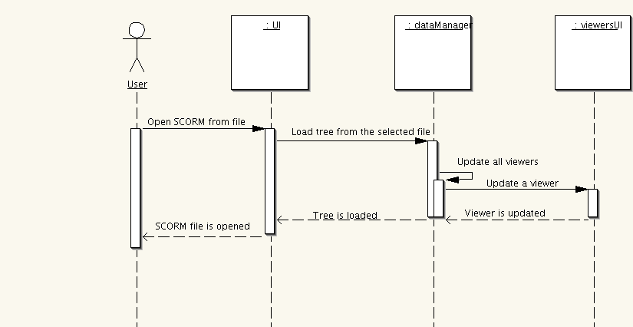

Display SCORM Relational Graph
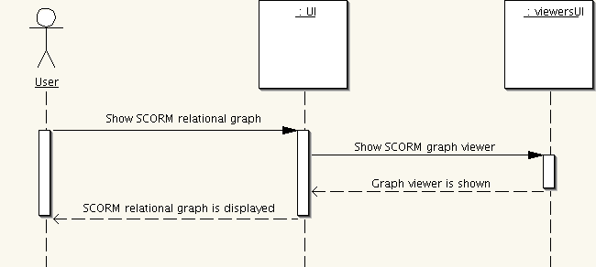

Display Attribute Display
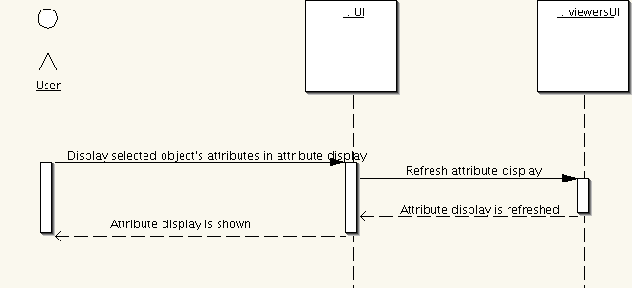

Hide Object Tree
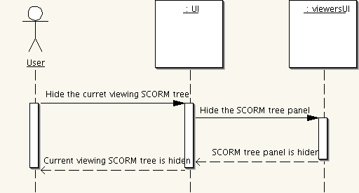

Show Object Tree
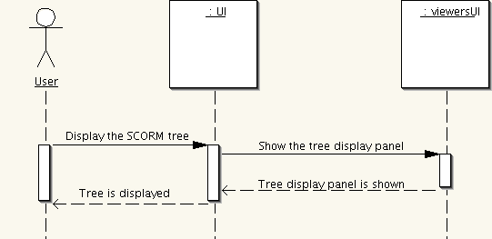

Save Object to Local File
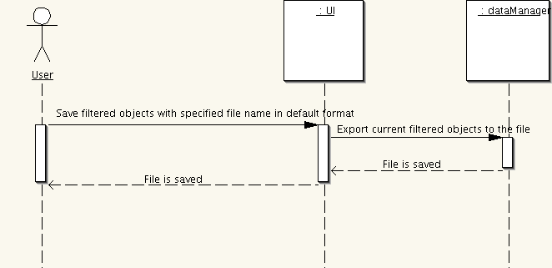

Save As Other Format
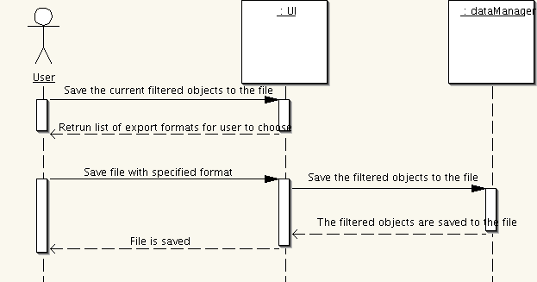

Cancel
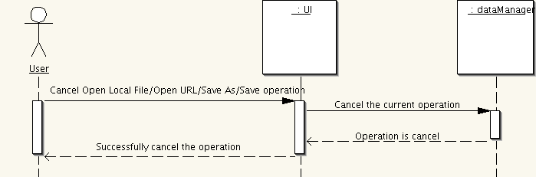

Help
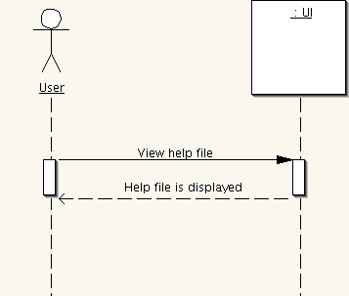

Forward
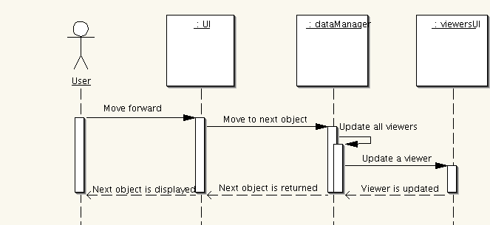

Back
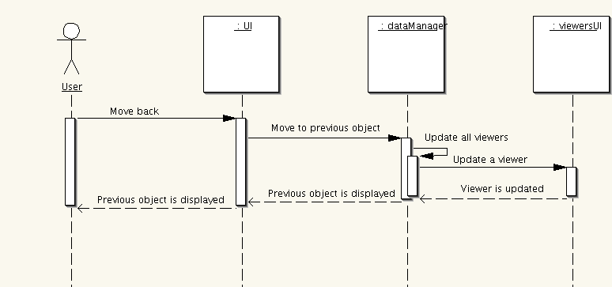

Select Object From History
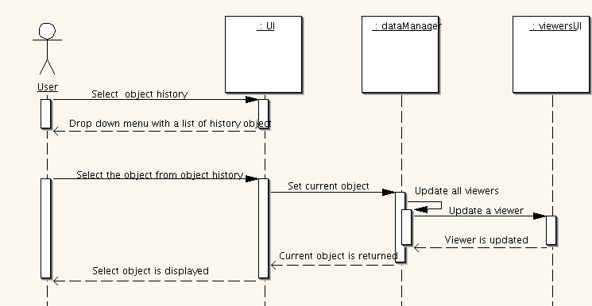

Select Object From Tree
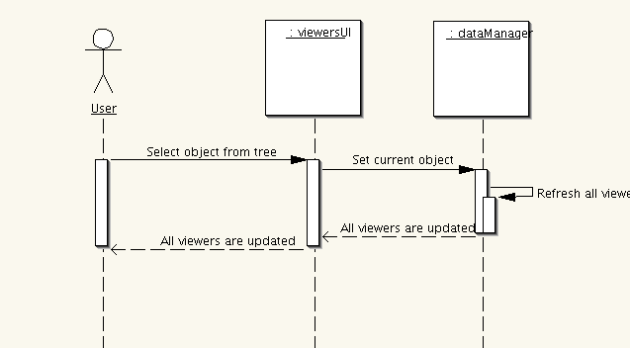

Select Object From Graph
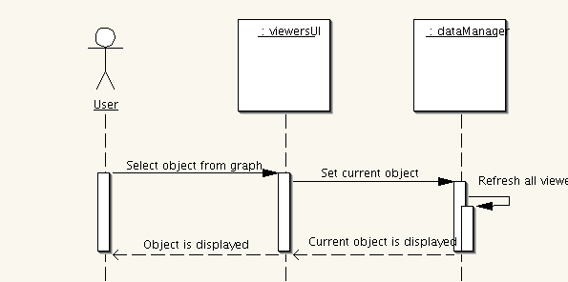

Select Object From Attribute Display
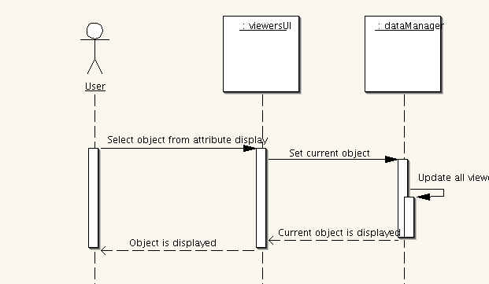

Select Attribute To Sort By
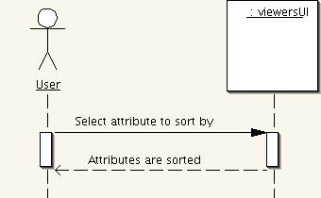

Select Attribute Filter
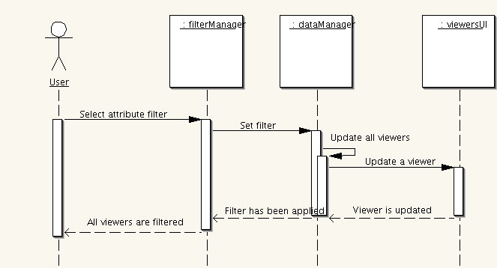

Create Attribute Filter
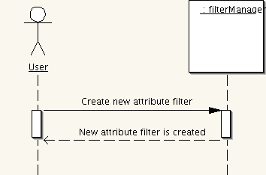

Modify Attribute Filter
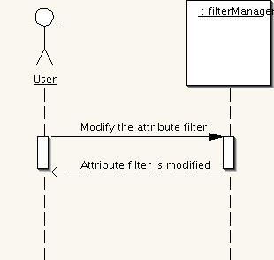

Delete Attribute Filter
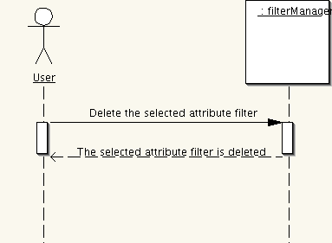

Select Object Filter
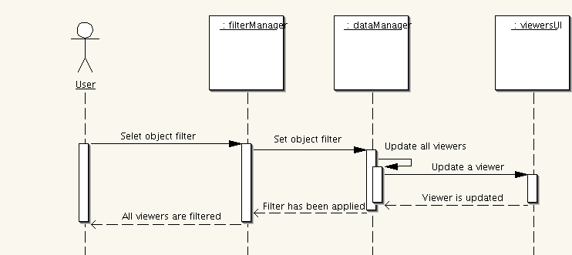

Create Object Filter
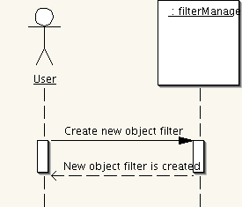

Modify Object Filter
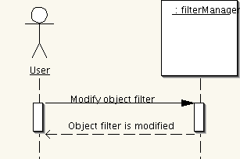

Delete Object Filter
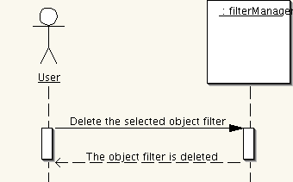

Low Level Design

Complete Static Model (Class Diagram)
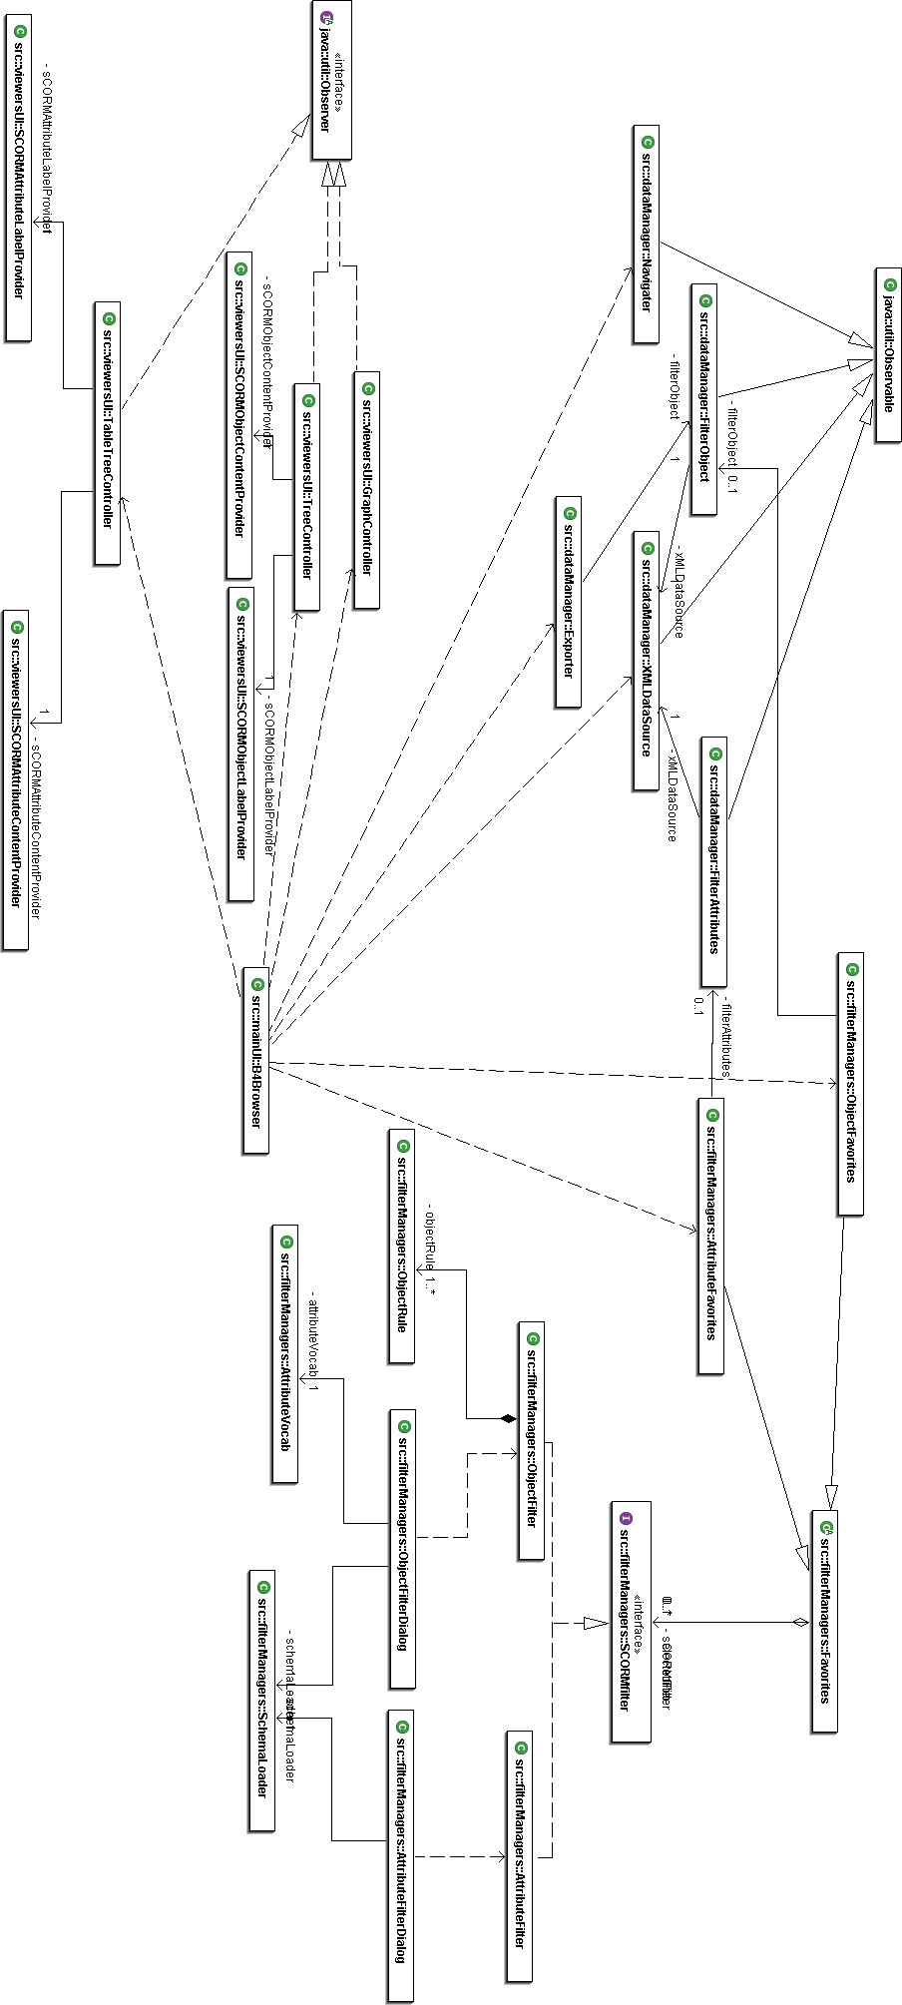

Main UI Package

Static Model (Class Diagram)

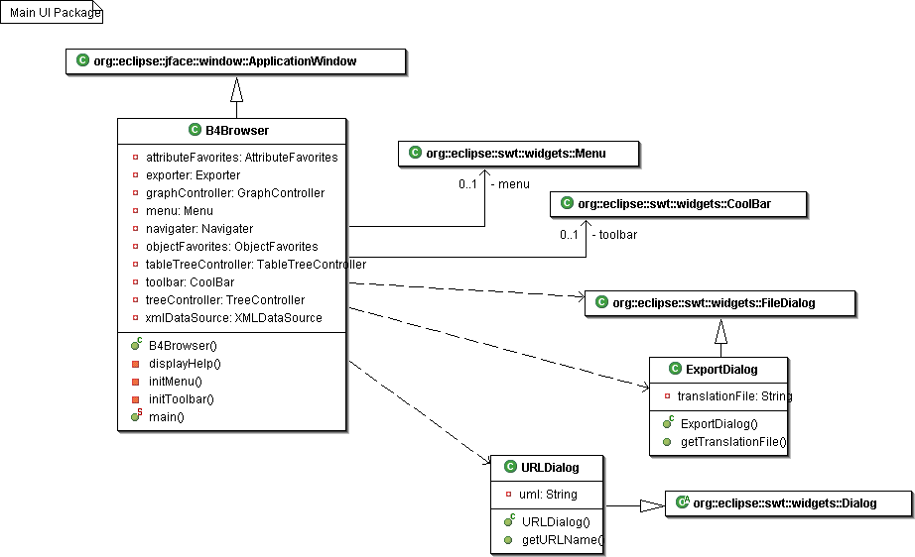

Dynamic Model (Sequence Diagrams)

Open URL
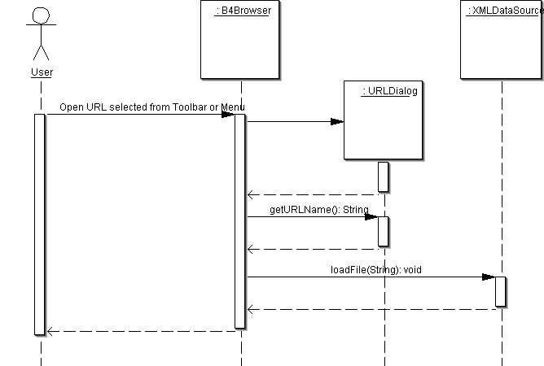

Open Local File
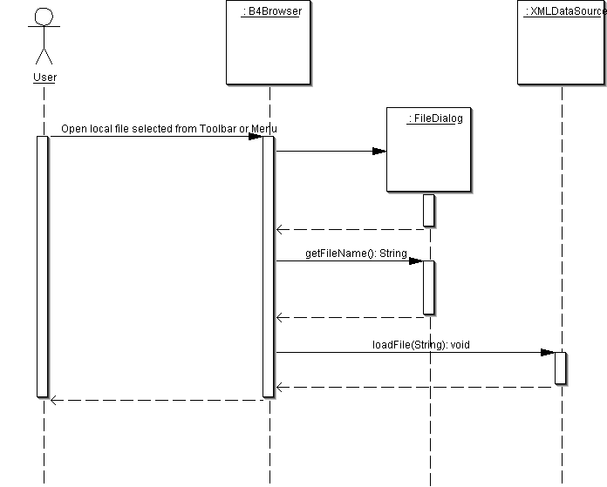

Display SCORM Relational Graph
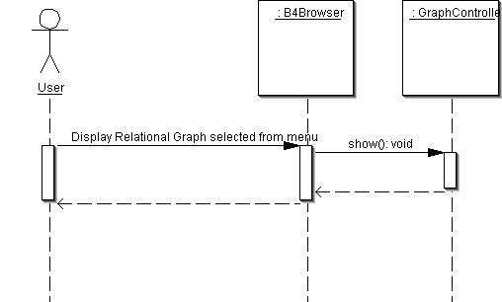

Display Attribute Display
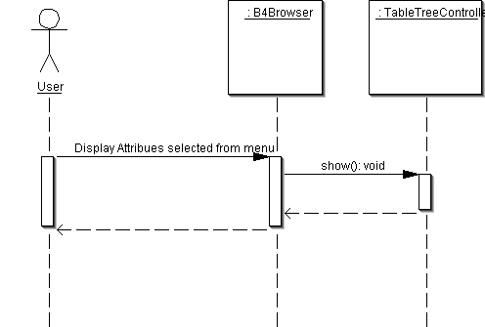

Hide Object Tree
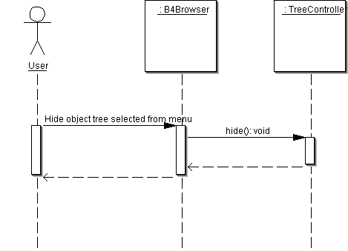

Show Object Tree
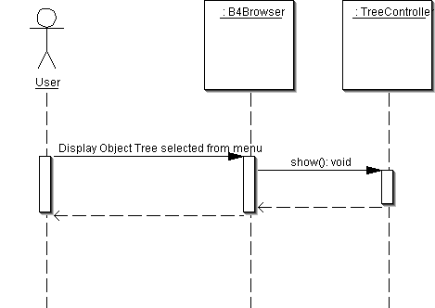

Save Object to Local File
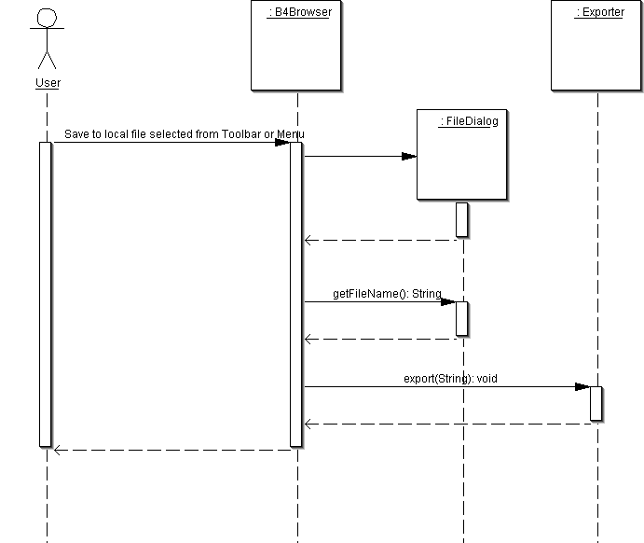

Save As Other Format
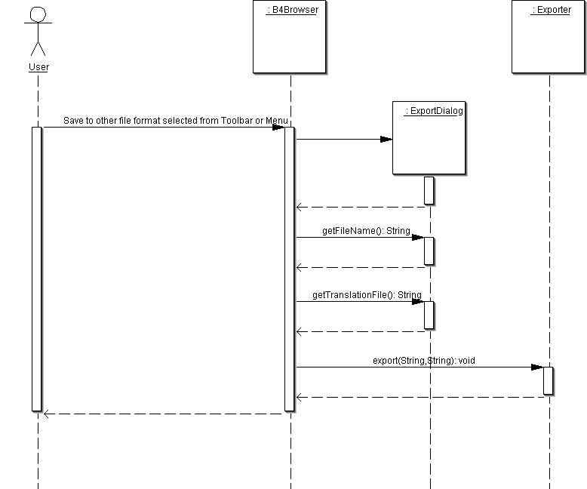

Cancel
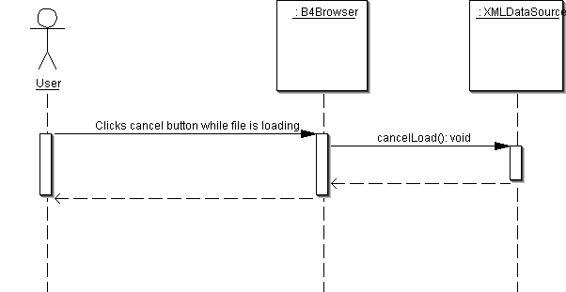

Help
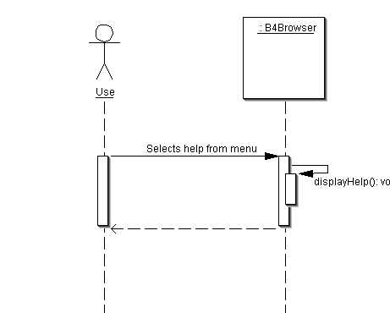

Forward
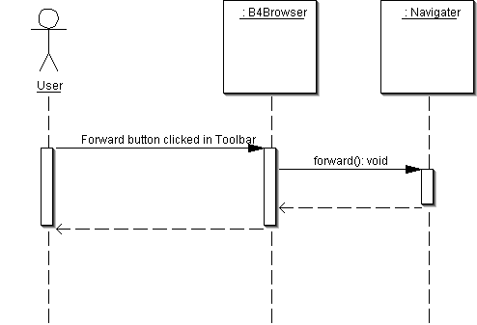

Back
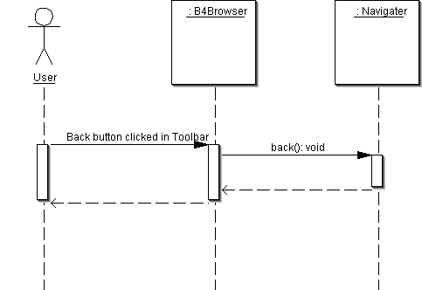

Select Object From History
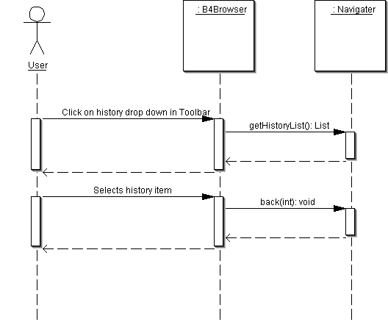

Data Manager Package

Static Model (Class Diagram)

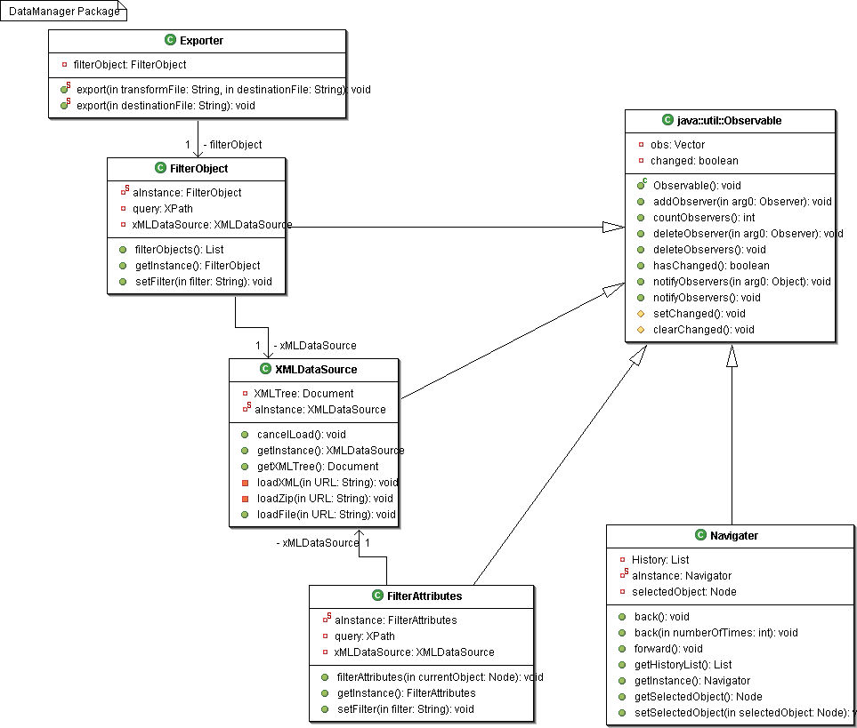

Dynamic Model (Sequence Diagrams)

Open URL, Open Local File
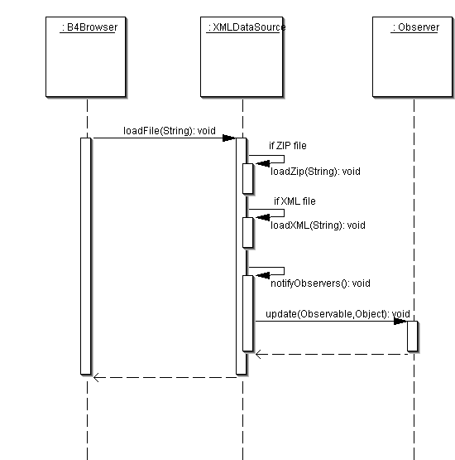

Save Object to Local File
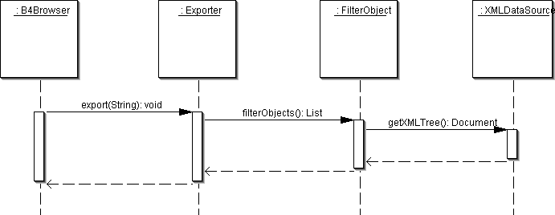

Save As Other Format
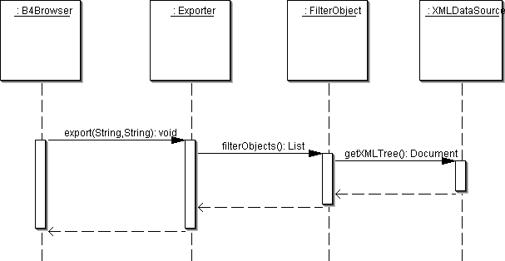

Cancel
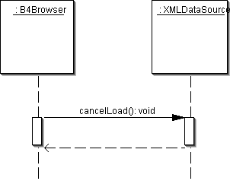

Forward
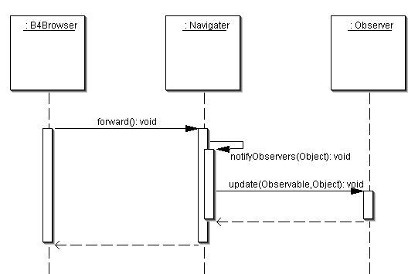

Back
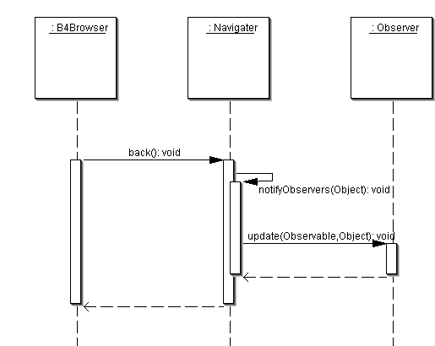

Select Object From History
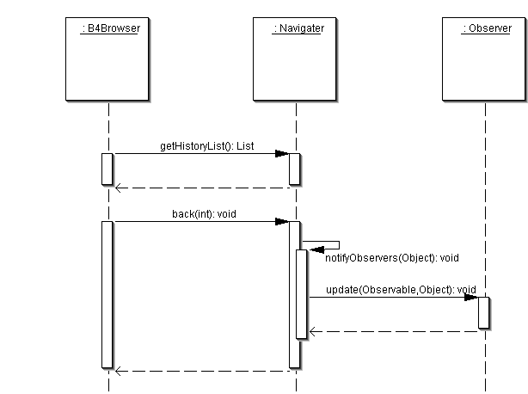

Select Object From Tree
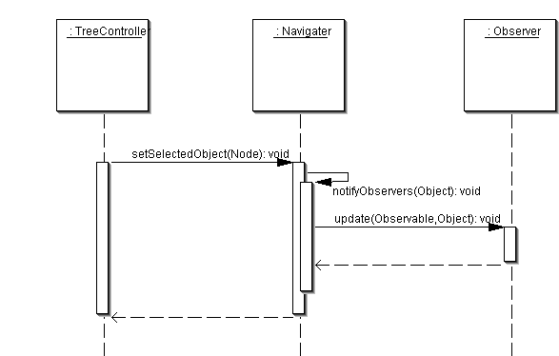

Select Object From Graph
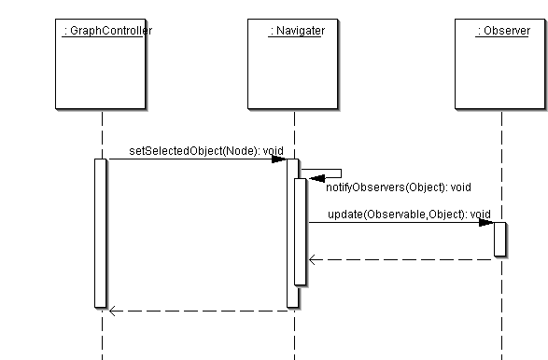

Select Object From Attribute Display
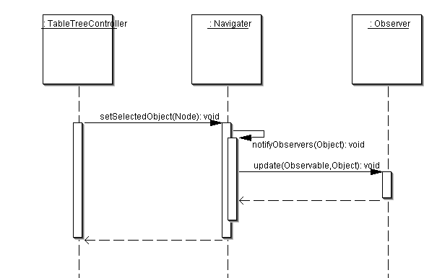

Select Attribute Filter
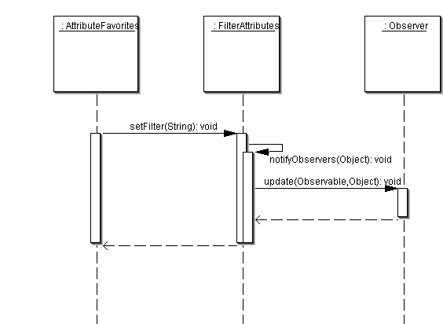

Select Object Filter
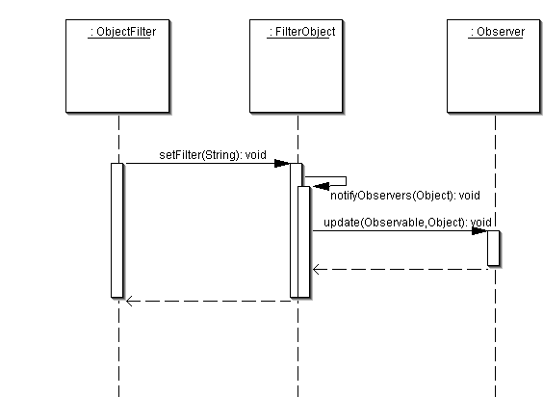

Filter Managers Package

Static Model (Class Diagram)

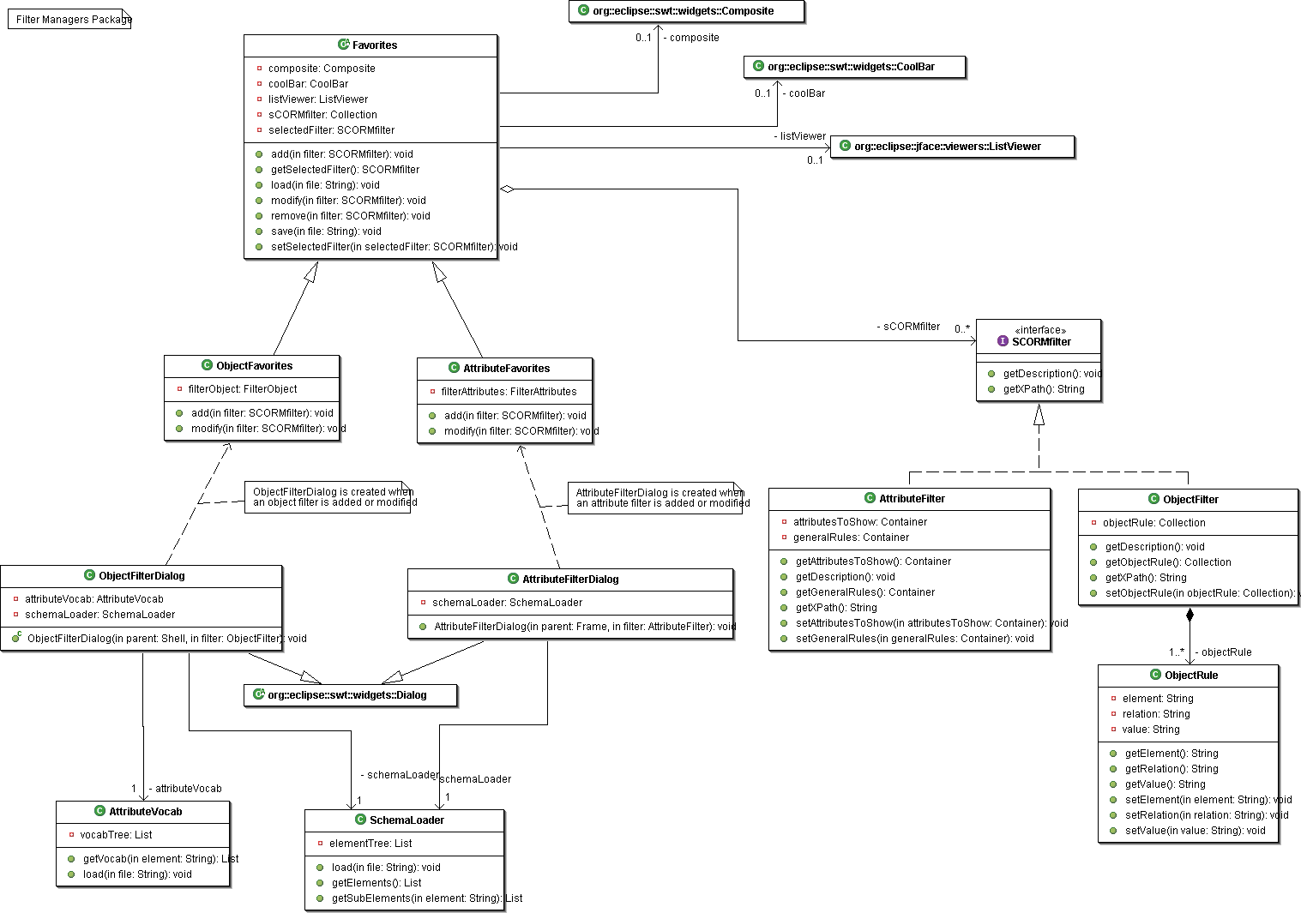

Dynamic Model (Sequence Diagrams)

Select Attribute Filter
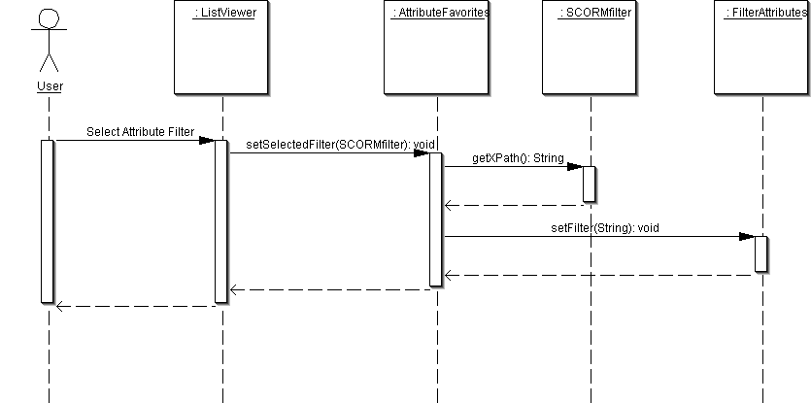

Create Attribute Filter
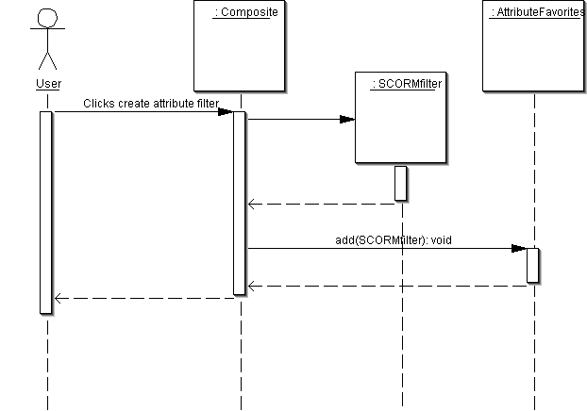

Modify Attribute Filter
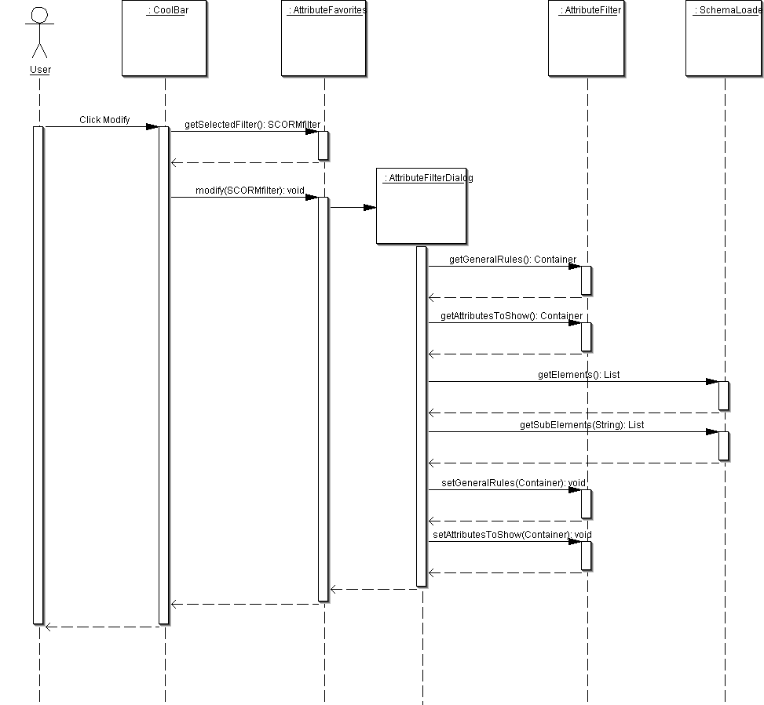

Select Object Filter
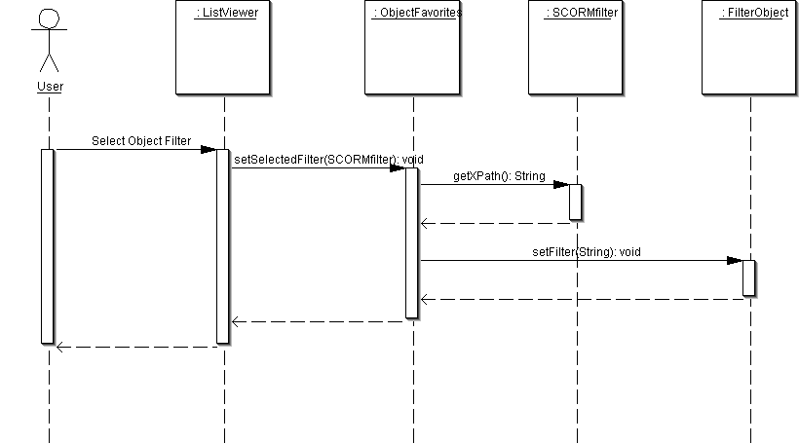

Create Object Filter

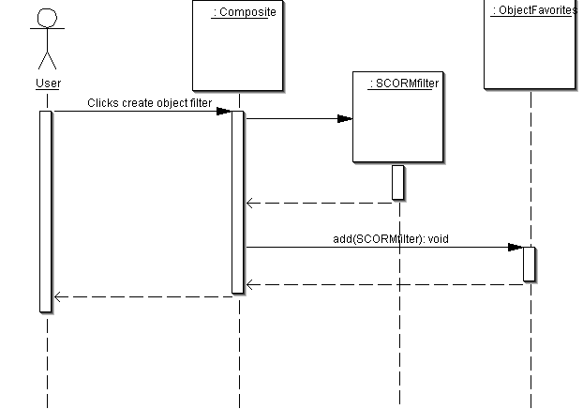

Modify Object Filter
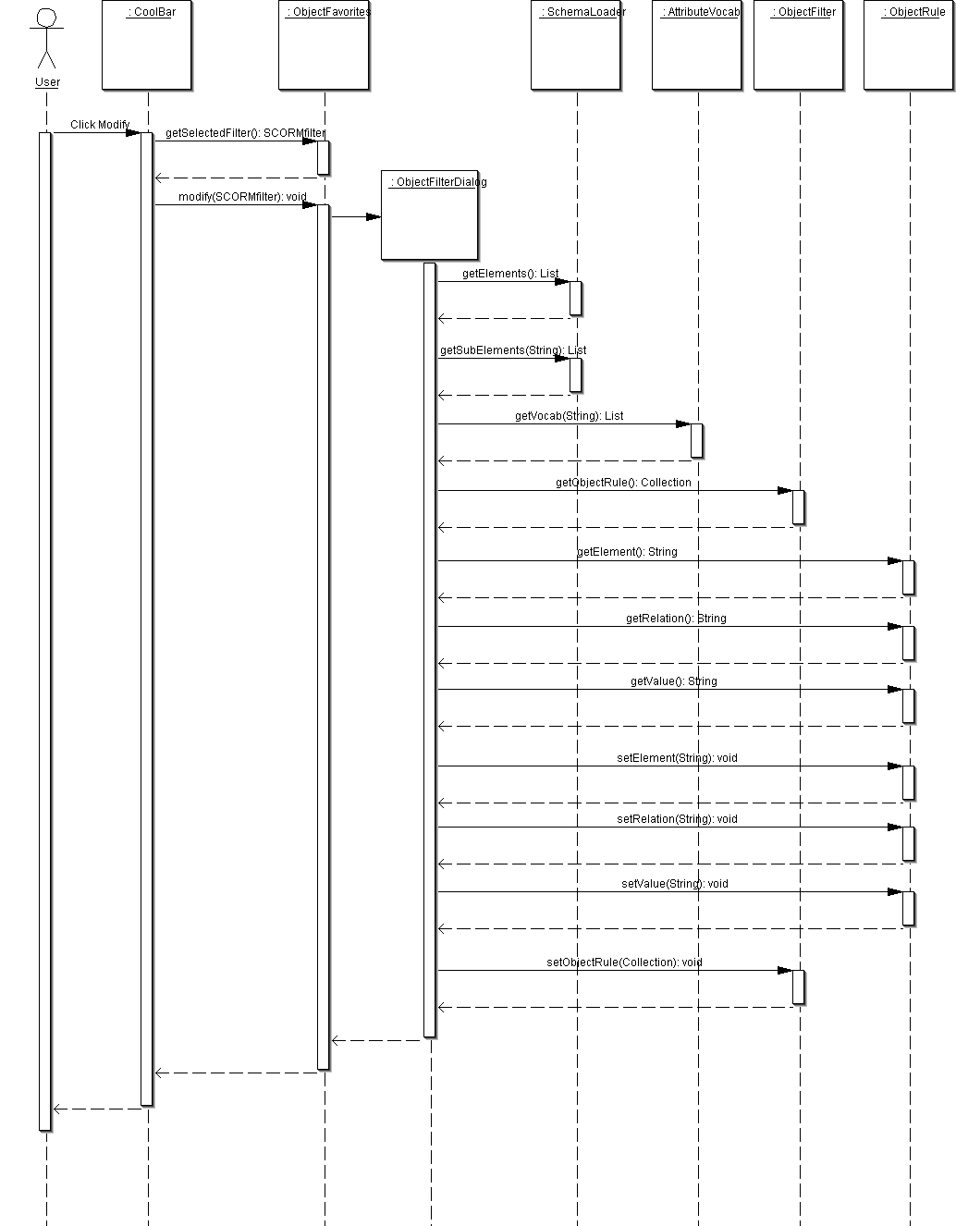

Delete Attribute Filter, Delete Object Filter
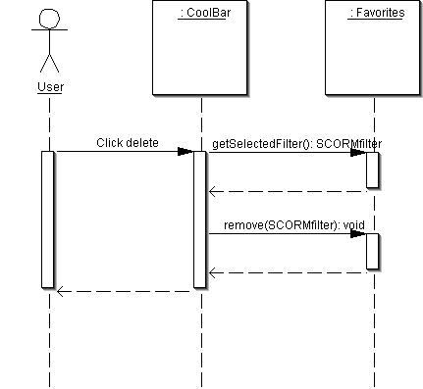

Viewers UI Package

Static Model (Class Diagram)

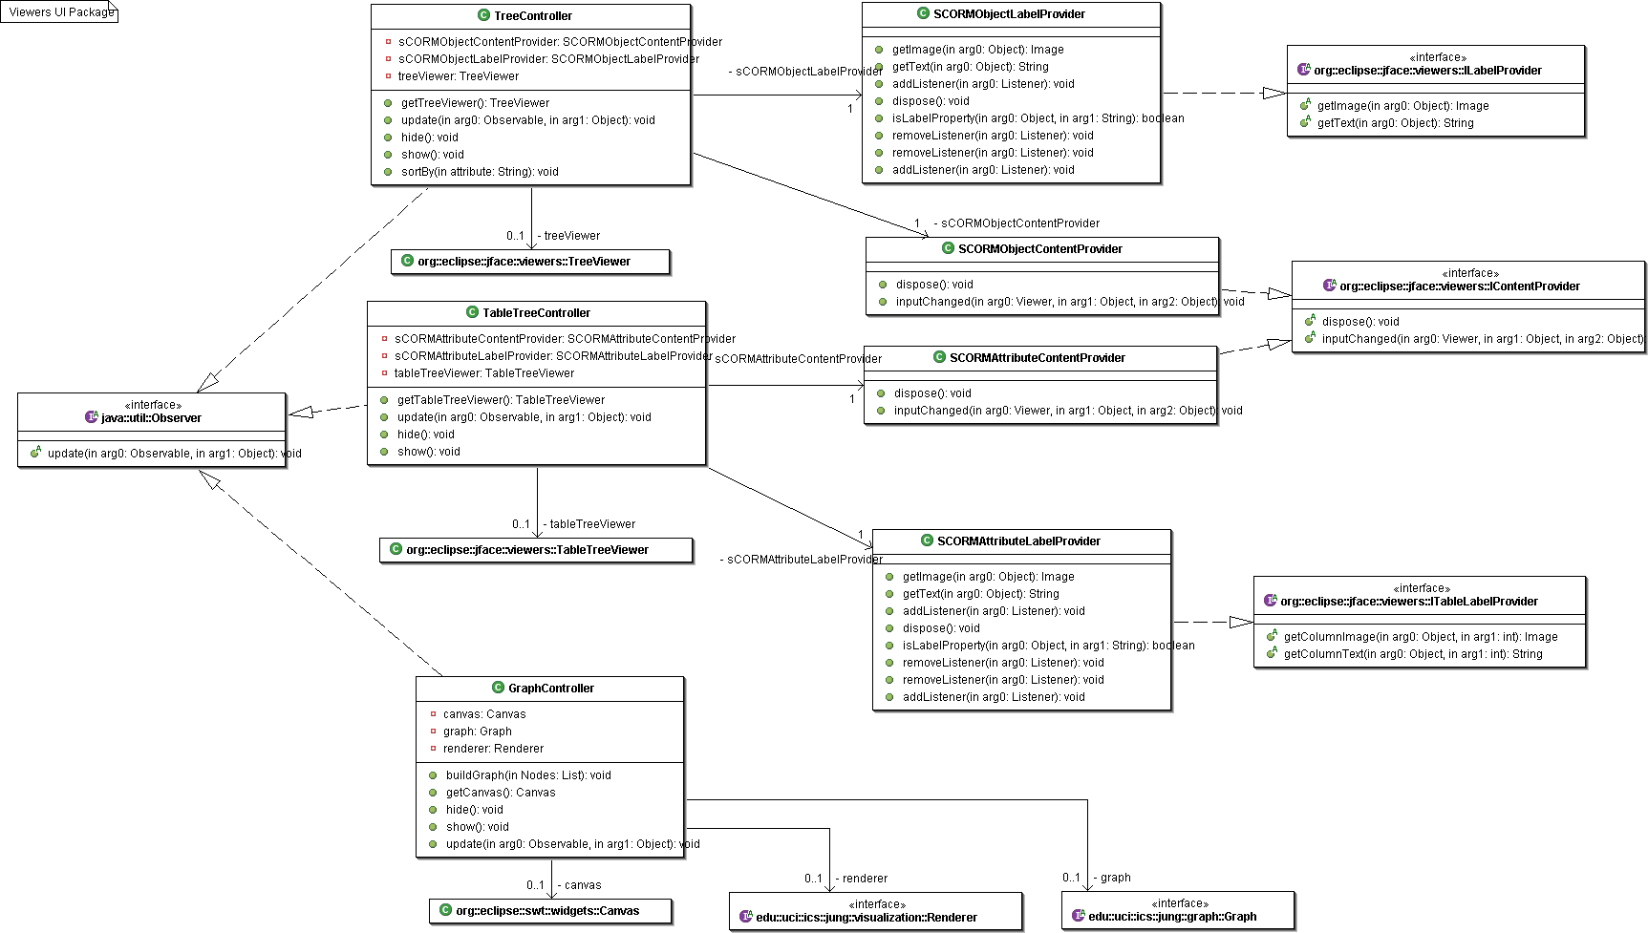

Dynamic Model (Sequence Diagrams)

Open URL, Open Local File, Forward, Back, Select Attribute Filter, Select Object Filter, Select Object From History
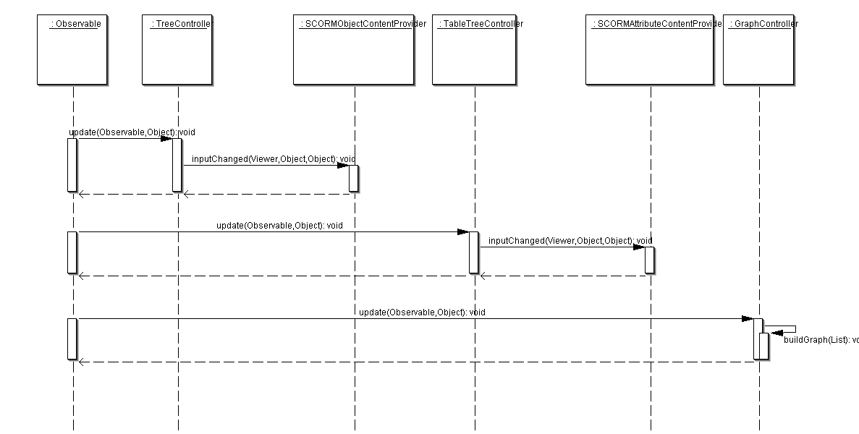

Display SCORM Relational Graph
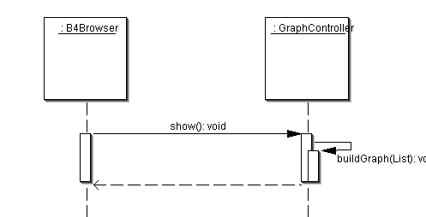

Display Attribute Display
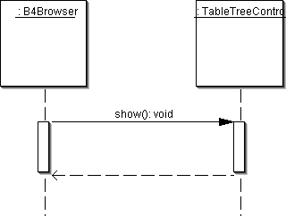

Hide Object Tree
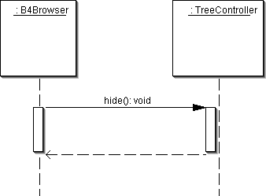

Show Object Tree
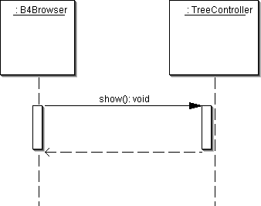

Select Object From Tree
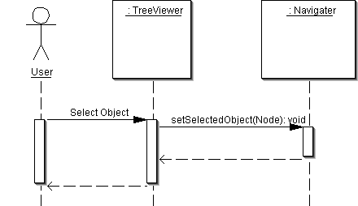

Select Object From Graph
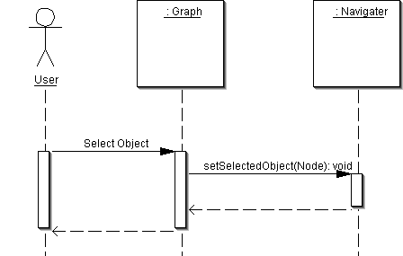

Select Object From Attribute Display
